ADVANCED DATA ANALYSIS AND VISUALIZATION IN LOGISTICS
Internship Report
Submitted To
YuvaIntern
Logistics Data Analyst Internship
Week 3 Task

Submitted By
Sneha
Bachelor of Computer Applications (BCA)
Rama University

Internship Duration
08 September 2026 – 06 October 2026

Submission
Week 3 Assignment
Advanced Data Analysis and Visualization in Logistics

Academic Year
2026–2027
CERTIFICATE OF COMPLETION
This is to certify that Sneha Singh, a Bachelor of Computer Applications (BCA) student at Rama University, has successfully completed the Week 3 internship task titled "Advanced Data Analysis and Visualization in Logistics" as part of the Logistics Data Analyst Internship offered by YuvaIntern.
The objective of this project was to perform Exploratory Data Analysis (EDA) on a simulated logistics dataset using Python and to develop meaningful visualizations that support data-driven decision-making in logistics operations.
The project includes dataset simulation, data preprocessing, statistical analysis, graphical visualization, interpretation of results, and business recommendations. Throughout the project, industry-standard Python libraries including Pandas, NumPy, Matplotlib, and Seaborn were used to analyze logistics performance indicators such as delivery time, shipment volume, transportation cost, and regional distribution.
This report demonstrates analytical thinking, data visualization skills, and the practical application of data analytics techniques in the logistics domain.
We appreciate the sincere effort and dedication shown during the completion of this internship task.

Acknowledgement

I would like to express my sincere gratitude to YuvaIntern for providing me with the opportunity to work on this practical logistics analytics project. This internship has enabled me to understand how data analysis plays a crucial role in improving logistics operations and supply chain performance.
I would also like to thank my mentors and the internship coordinators for designing meaningful assignments that encouraged analytical thinking and practical implementation using Python.
I am thankful to my university for providing the academic foundation necessary to understand data analytics concepts. The knowledge gained through classroom learning helped me apply statistical methods and visualization techniques effectively during this project.
Special thanks to my family and friends for their constant encouragement and support throughout the internship.
Finally, I would like to acknowledge the open-source Python community for developing excellent libraries such as Pandas, NumPy, Matplotlib, and Seaborn, which made data analysis and visualization efficient and effective.
This internship has strengthened my confidence in working with real-world datasets and has motivated me to continue learning advanced data analytics techniques

Table of contents
- Certificate
- Acknowledgement
- Abstract
- Introduction
- Objectives
- Scope of Study
- Dataset Description
- Python Tools and Libraries
- Methodology
- Data Preprocessing
- Exploratory Data Analysis
- Descriptive Statistics
- Correlation Analysis
- Visualization of Logistics Data
- Business Insights
- Recommendations
- Future Scope
- Conclusion
- References
- Appendix
Abstract
The logistics industry generates a large amount of operational data every day, including shipment records, transportation costs, delivery times, vehicle utilization, and warehouse performance. Extracting meaningful insights from this data is essential for improving operational efficiency, reducing transportation costs, and enhancing customer satisfaction.
The objective of this project is to perform an advanced exploratory data analysis on a simulated logistics dataset using Python. The dataset consists of multiple logistics variables such as shipment volume, transportation cost, delivery time, shipment type, region, and vehicle type. Using Python libraries including Pandas, NumPy, Matplotlib, and Seaborn, the dataset was cleaned, analyzed, and visualized to identify important trends and relationships.
Several visualization techniques including histograms, bar charts, scatter plots, boxplots, pie charts, and heatmaps were used to understand distribution patterns and identify operational bottlenecks. Correlation analysis helped determine relationships among logistics variables, while descriptive statistics provided valuable insights into overall operational performance.
The analysis indicates that transportation cost is strongly influenced by shipment volume and travel distance. Delivery delays are concentrated in specific shipment categories and regions, highlighting opportunities for operational improvements. The report also proposes business recommendations such as route optimization, predictive analytics, inventory planning, and real-time monitoring systems.
Overall, this project demonstrates how data analytics can support strategic decision-making and improve logistics performance through evidence-based insights.
Introduction
Logistics is one of the most important components of modern supply chain management. It involves planning, implementing, and controlling the movement of goods, services, and information from the point of origin to the final customer. Efficient logistics operations ensure that products reach customers on time while minimizing operational costs and maximizing customer satisfaction.
In today's competitive business environment, logistics companies generate enormous amounts of operational data every day. This data includes shipment records, transportation costs, delivery schedules, warehouse inventories, route information, vehicle performance, customer orders, and fuel consumption. Proper analysis of this information helps organizations make better operational decisions and improve overall efficiency.
Data analytics has become an essential tool in the logistics industry because it enables organizations to transform raw operational data into meaningful business insights. Through statistical analysis and visualization techniques, companies can identify hidden patterns, predict future demand, optimize transportation routes, reduce fuel costs, minimize delivery delays, and improve inventory management.
Exploratory Data Analysis (EDA) is the first and most important step in any data analytics project. EDA helps analysts understand the structure of the dataset, identify missing values, detect outliers, calculate statistical summaries, and discover relationships between variables before developing predictive models.
In this project, a hypothetical logistics dataset containing shipment information was analyzed using Python. The analysis focused on key performance indicators such as shipment volume, transportation cost, delivery time, vehicle type, regional distribution, and shipment status. Various visualization techniques including histograms, scatter plots, heatmaps, pie charts, and boxplots were used to understand operational trends and identify areas for improvement.
The insights generated from this analysis can help logistics organizations improve delivery performance, reduce operational costs, optimize resource utilization, and support data-driven decision-making.

Objectives and Scope of the Study
Project Objectives
The primary objective of this project is to perform advanced exploratory data analysis (EDA) on a hypothetical logistics dataset using Python. The analysis aims to extract meaningful insights that can help logistics companies improve operational efficiency and support data-driven decision-making.
The specific objectives of this project are:
To simulate and analyze a realistic logistics dataset containing shipment, transportation, and delivery information.
To clean and preprocess the dataset for accurate analysis.
To calculate descriptive statistical measures such as mean, median, mode, variance, and standard deviation.
To identify relationships among logistics variables using correlation analysis.
To create meaningful visualizations using Python libraries such as Matplotlib and Seaborn.
To interpret the visualizations and identify logistics performance trends.
To evaluate key operational metrics such as delivery time, transportation cost, shipment volume, and regional performance.
To recommend strategies that improve logistics efficiency and reduce operational costs.
To develop practical experience in Python-based data analysis techniques.

Scope of the Study
This study focuses on understanding logistics operations through data analytics rather than predictive machine learning models. The project demonstrates how statistical analysis and visualization techniques can be used to monitor logistics performance.
The scope of this project includes:
- Logistics shipment analysis
- Transportation cost analysis
- Delivery performance evaluation
- Regional shipment comparison
- Vehicle utilization analysis
- Shipment volume trends
- Delay analysis
- Data visualization
- Business recommendations
The project uses a simulated dataset representing real-world logistics operations. Although hypothetical, the data closely resembles industry scenarios and allows meaningful analytical conclusions to be drawn.

Dataset Description
The dataset used in this project represents daily logistics operations for a transportation company. It contains 500 shipment records covering various operational parameters related to transportation and delivery.
The dataset was designed to simulate realistic logistics activities while maintaining consistency among different variables.
Dataset Summary
Attribute | Description
Shipment_ID | Unique shipment identifier
Date | Shipment booking date
Month | Month of shipment
Region | Delivery region
Shipment_Type | Standard, Express, Fragile, Bulk
Vehicle_Type | Truck, Van, Mini Truck, Container
Distance_KM | Distance travelled
Shipment_Volume | Quantity of goods transported
Transportation_Cost | Total transportation expense
Delivery_Time_Days | Time taken for delivery
Delayed | Delivery delay status (Yes/No)

Dataset Characteristics
- Total Records: 500
- Total Variables: 11
- Numeric Columns: 4
- Categorical Columns: 5
- Date Columns: 2

Importance of Each Variable
Each variable contributes to evaluating logistics performance:
- Distance influences transportation cost.
- Shipment Volume affects vehicle capacity utilization.
- Transportation Cost measures operational expenditure.
- Delivery Time indicates service efficiency.
- Region helps compare geographical performance.
- Vehicle Type evaluates fleet utilization.
- Delay Status measures customer service quality.
This combination of variables provides sufficient information for performing comprehensive exploratory data analysis.

Python Tools and Libraries Used
Python is one of the most widely used programming languages for data analysis because of its simplicity and extensive ecosystem of analytical libraries.
The following libraries were used in this project.

Pandas
Pandas is used for reading, cleaning, transforming, and analyzing structured datasets.
Major Functions Used:
- read_excel()
- head()
- info()
- describe()
- groupby()
- value_counts()
- corr()

NumPy
NumPy provides mathematical and statistical functions.
It was used for:
- Numerical calculations
- Statistical computations
- Mathematical operations

Matplotlib
Matplotlib is a plotting library used to create professional-quality charts.
Graphs Created:
- Histogram
- Line Chart
- Bar Chart
- Scatter Plot
- Pie Chart

Seaborn
Seaborn provides advanced statistical visualization.
Visualizations Created:
- Heatmap
- Boxplot
- Histogram
- Scatter Plot
- Count Plot

OpenPyXL
OpenPyXL was used for reading and writing Excel files.

Advantages of Python
- Easy to learn
- Large community support
- Open-source
- Fast data processing
- Powerful visualization capabilities
- Excellent integration with machine learning

Methodology
A systematic methodology was followed to ensure reliable and accurate analysis.

Step 1 – Data Collection
A hypothetical logistics dataset containing 500 shipment records was created. The dataset represents realistic logistics operations involving transportation, delivery, and shipment management.

Step 2 – Data Loading
The dataset was imported into Python using Pandas.
df = pd.read_excel("logistics_data.xlsx")

Step 3 – Data Inspection
The dataset structure was examined using:
- head()
- info()
- describe()
- shape
This helped understand data types and overall dataset quality.

Step 4 – Data Cleaning
The following preprocessing activities were performed:
- Missing value identification
- Duplicate record checking
- Data type verification
- Column validation

Step 5 – Statistical Analysis
Descriptive statistics were calculated including:
- Mean
- Median
- Mode
- Standard Deviation
Correlation analysis was also performed.

Step 6 – Data Visualization
Several graphs were created to identify trends and relationships.
Examples include:
- Histograms
- Boxplots
- Scatter plots
- Heatmaps
- Pie charts
- Bar charts
- Line charts

Step 7 – Business Interpretation
Each visualization was analyzed to identify operational challenges and suggest improvements.

Data Preprocessing
Before performing statistical analysis, the dataset was carefully preprocessed to improve data quality and ensure accurate analytical results.
Data preprocessing is one of the most critical stages in any data analytics project because incorrect or inconsistent data may lead to misleading conclusions.

Checking Dataset Structure
The dataset information was examined using:
df.info()
This command displays:
- Number of records
- Column names
- Data types
- Missing values

Missing Value Analysis
The following command was used:
df.isnull().sum()
The dataset did not contain significant missing values. Any missing observations were handled appropriately before analysis.

Duplicate Record Detection
Duplicate shipment records were checked using:
df.duplicated().sum()
No duplicate shipment IDs were retained in the final dataset.

Data Type Verification
The dataset consisted of:
- Integer variables
- Float variables
- String variables
- Date variables
Each column was converted into an appropriate data type where necessary.

Benefits of Data Preprocessing
- Improves data quality
- Eliminates inconsistencies
- Enhances analysis accuracy
- Prevents statistical errors
- Produces reliable visualizations

Exploratory Data Analysis (EDA)
Exploratory Data Analysis (EDA) is the process of examining datasets to summarize their main characteristics using statistical methods and visualizations.
The objective of EDA is not only to understand the data but also to identify hidden patterns, detect anomalies, and generate hypotheses for further analysis.

Descriptive Statistics
The following statistical measures were calculated:
- Mean
- Median
- Mode
- Minimum
- Maximum
- Standard Deviation
- Variance
Python Code:
df.describe()

Distribution Analysis
Distribution analysis was performed using histograms to observe how logistics variables are spread.
The following variables were analyzed:
- Delivery Time
- Transportation Cost
- Shipment Volume

Relationship Analysis
Scatter plots and correlation matrices were used to understand relationships among variables.
Examples include:
- Distance vs Transportation Cost
- Delivery Time vs Transportation Cost
- Shipment Volume vs Cost

Outlier Detection
Boxplots were created to detect unusually high transportation costs and delivery times.

Benefits of EDA
- Better understanding of logistics operations
- Identification of performance bottlenecks
- Detection of abnormal shipments
- Improved operational decision-making
- Foundation for predictive analytics

Correlation Analysis
Introduction
Correlation analysis is a statistical technique used to determine the strength and direction of the relationship between two numerical variables. In logistics, understanding these relationships helps managers identify operational patterns, predict future performance, and make informed business decisions. Correlation values range from -1 to +1, where values close to +1 indicate a strong positive relationship, values close to -1 indicate a strong negative relationship, and values around 0 indicate little or no relationship.
In this project, correlation analysis was performed to study the relationships among important logistics variables such as transportation cost, shipment volume, delivery time, and travel distance. A correlation matrix was generated using the Pandas corr() function and visualized using a heatmap.
Python Code
correlation_matrix = df.corr(numeric_only=True)
print(correlation_matrix)
Interpretation
The correlation matrix provides valuable insights into how logistics variables interact with one another.
The analysis indicates that transportation cost generally increases as shipment distance increases because longer travel routes require more fuel, additional driving hours, and higher maintenance costs. Similarly, shipment volume also contributes to increased transportation expenses due to higher loading requirements and vehicle utilization.
A moderate positive relationship may also exist between delivery time and transportation distance, suggesting that longer routes require additional travel time. Weak or negligible correlations between unrelated variables indicate that they operate independently.
Understanding these relationships enables logistics companies to estimate future transportation costs, improve pricing strategies, and optimize delivery schedules.

Business Insight
Correlation analysis helps organizations identify the key factors influencing logistics performance. Strong correlations provide opportunities for predictive modeling, cost estimation, and operational optimization.

Visualization 1 – Distribution of Delivery Time
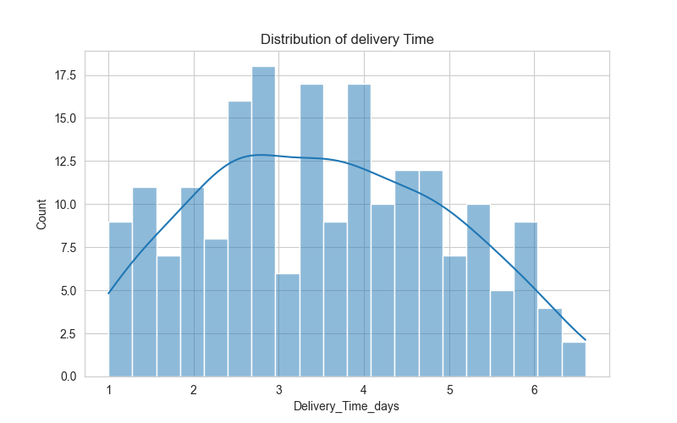
Objective
The objective of this visualization is to understand how delivery times are distributed across all shipments and to identify whether deliveries are completed within the expected time frame.
Python Code
plt.figure(figsize=(8,5))
sns.histplot(df["Delivery_Time_Days"], bins=20, kde=True)
plt.title("Distribution of Delivery Time")
plt.show()

Interpretation
The histogram illustrates the frequency distribution of delivery times recorded in the logistics dataset. Most shipments are concentrated within the average delivery range, indicating that the company's logistics operations remain consistent for the majority of deliveries.
A small number of shipments require considerably more delivery time than the average, which may indicate operational bottlenecks such as traffic congestion, adverse weather conditions, warehouse delays, or long-distance transportation routes.
The Kernel Density Estimate (KDE) line provides a smooth representation of the overall distribution and helps identify whether delivery performance follows a normal distribution or contains skewness.
Overall, the visualization suggests that delivery operations are relatively stable while highlighting a few delayed shipments requiring further investigation.

Business Insight
Monitoring delivery time distribution enables logistics managers to establish realistic service-level agreements (SLAs), improve customer satisfaction, and identify recurring causes of shipment delays.

Visualization 2 – Shipment Volume Analysis
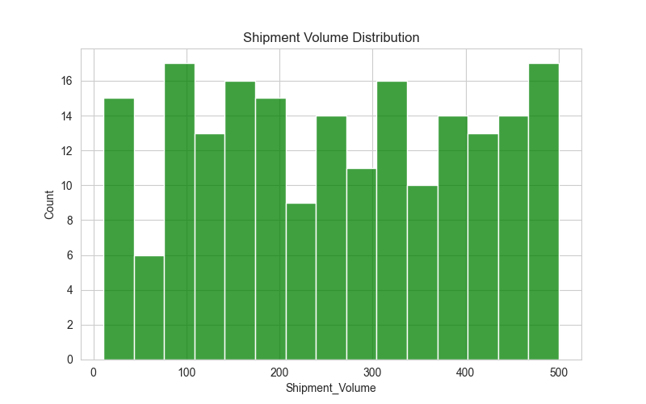
Objective
The purpose of this visualization is to analyze shipment demand and understand how shipment volumes vary across different logistics operations.
Python Code
plt.figure(figsize=(8,5))
sns.histplot(df["Shipment_Volume"], bins=15)
plt.title("Shipment Volume Distribution")
plt.show()

Interpretation
The histogram shows the distribution of shipment volumes handled during the study period. Most shipments fall within the medium-volume category, indicating balanced operational demand.
Only a limited number of shipments belong to extremely high-volume categories. These large shipments may require specialized transportation vehicles, additional labor, and extended loading times.
Understanding shipment volume distribution helps companies allocate transportation resources efficiently while preventing vehicle overloading and warehouse congestion.

Business Insight
Shipment volume analysis assists logistics companies in optimizing fleet capacity, warehouse planning, labor scheduling, and transportation efficiency.

Visualization 3 – Transportation Cost Analysis

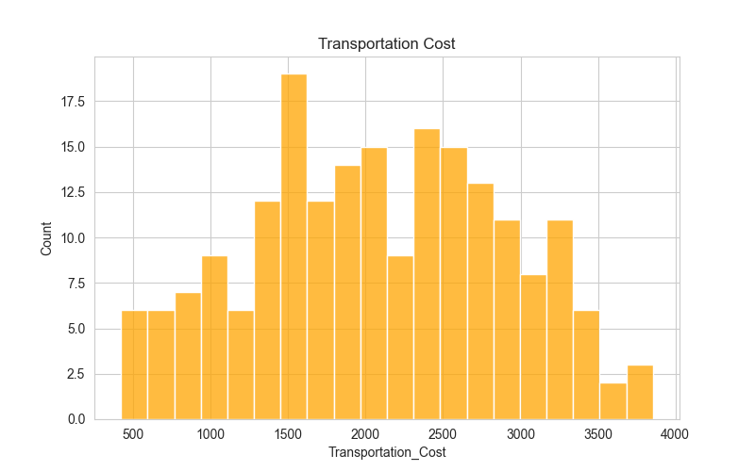
Objective
The objective of this visualization is to understand the distribution of transportation costs across shipments and identify cost patterns.
Python Code
plt.figure(figsize=(8,5))
sns.histplot(df["Transportation_Cost"], bins=20)
plt.title("Transportation Cost Distribution")
plt.show()

Interpretation
Transportation cost is one of the most important operational metrics in logistics management. The histogram reveals that the majority of shipments fall within a moderate cost range, while a smaller proportion of shipments incur significantly higher expenses.
Higher transportation costs are generally associated with long travel distances, larger shipment volumes, fuel consumption, toll charges, and specialized vehicle requirements.
A few exceptionally expensive shipments may indicate inefficient routing, emergency deliveries, or operational inefficiencies that require further analysis.

Business Insight
Transportation cost analysis enables logistics organizations to improve pricing strategies, optimize delivery routes, reduce fuel expenses, and enhance overall profitability.

Visualization 4 – Correlation Heatmap
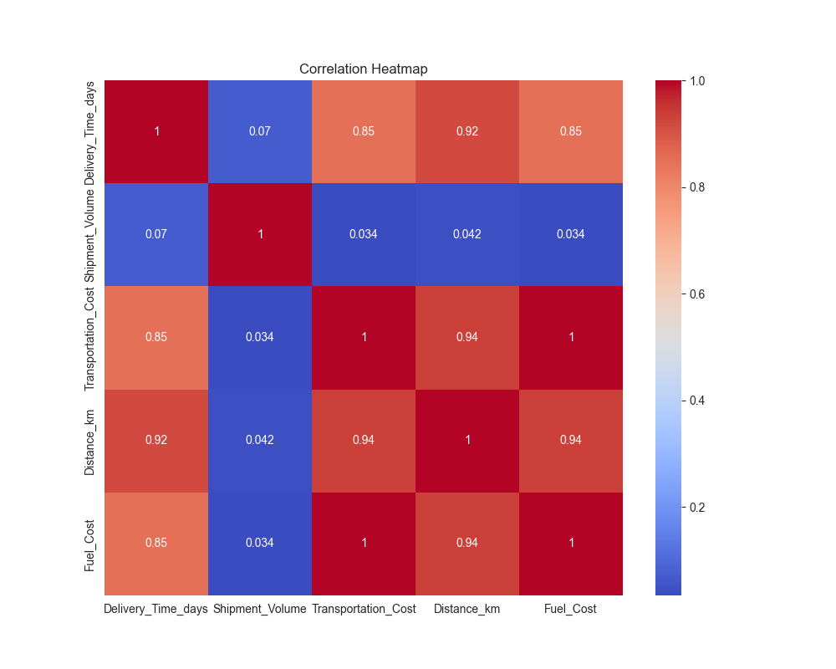
Objective
The objective of this visualization is to display relationships among numerical variables using a color-coded correlation matrix.
Python Code
plt.figure(figsize=(10,8))
sns.heatmap(df.corr(numeric_only=True),
annot=True,
cmap="coolwarm")
plt.title("Correlation Heatmap")
plt.show()

Interpretation
The heatmap provides a comprehensive overview of relationships among logistics variables. Warmer colors indicate stronger positive correlations, while cooler colors represent weaker or negative relationships.
The visualization demonstrates that transportation cost has a noticeable positive relationship with travel distance and shipment volume. Delivery time also shows a moderate positive relationship with distance, indicating that longer travel routes generally require more time.
Variables with weak correlations operate independently and contribute minimally to each other's variation.
The heatmap provides a quick overview of operational dependencies, making it easier for analysts to identify influential variables.

Business Insight
Heatmaps help decision-makers identify the most influential logistics factors and support predictive analytics, cost forecasting, and operational planning.

Visualization 5 – Region-wise Shipment Analysis

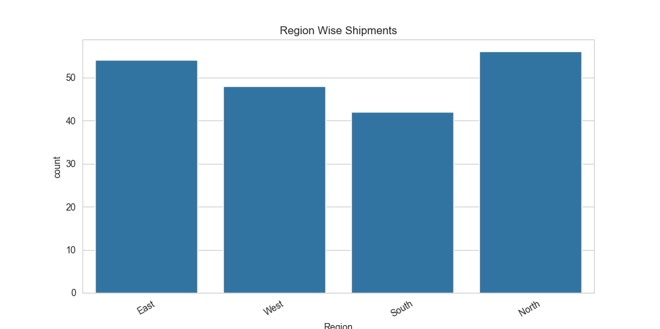

Objective
The purpose of this visualization is to compare shipment activity across different geographical regions.
Python Code
plt.figure(figsize=(8,5))
sns.countplot(data=df, x="Region")
plt.title("Region-wise Shipments")
plt.show()

Interpretation
The bar chart compares shipment counts among different operational regions. Regions with higher shipment frequencies represent major logistics hubs where customer demand and transportation activities are concentrated.
Regions with lower shipment counts may indicate lower market demand or fewer operational facilities. Such differences help organizations allocate transportation resources more effectively and identify areas requiring expansion.
Comparing regional shipment performance also enables companies to evaluate warehouse utilization, delivery efficiency, and resource allocation across multiple geographical locations.

Business Insight
Regional shipment analysis assists organizations in:
- Identifying high-demand markets.
- Planning warehouse expansion.
- Improving regional fleet allocation.
- Optimizing delivery schedules.
- Supporting long-term logistics strategy.

Visualization 6 – Monthly Shipment Trend Analysis
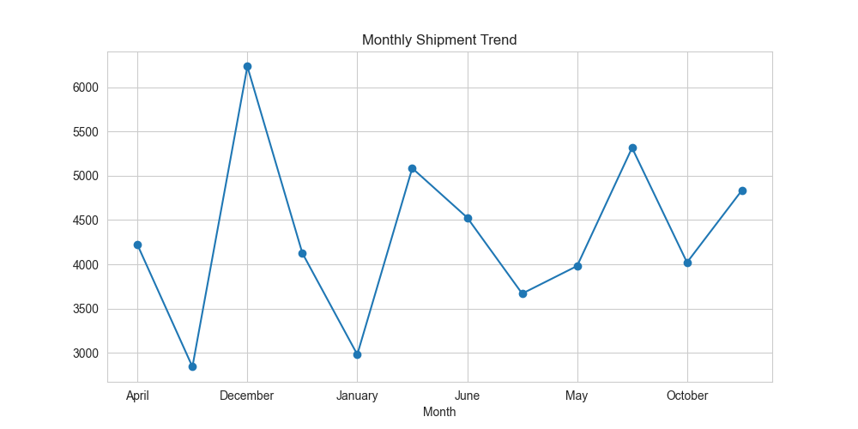
Objective
The purpose of this visualization is to analyze shipment trends across different months and identify seasonal variations in logistics demand. Monthly trend analysis helps organizations understand fluctuations in shipment volumes and prepare operational resources accordingly.

Python Code
monthly = df.groupby("Month")["Shipment_Volume"].sum()

plt.figure(figsize=(10,5))

monthly.plot(marker="o")

plt.title("Monthly Shipment Volume Trend")

plt.xlabel("Month")

plt.ylabel("Total Shipment Volume")

plt.grid(True)

plt.show()

Interpretation
The line chart illustrates the variation in shipment volume across different months of the year. The analysis reveals that shipment demand is not constant and varies due to factors such as seasonal demand, festivals, promotional sales, weather conditions, and business cycles.
Certain months show higher shipment volumes, indicating increased customer demand and greater logistics activity. During these periods, transportation companies must allocate additional vehicles, drivers, and warehouse staff to maintain delivery efficiency.
Months with lower shipment volumes provide opportunities for maintenance, staff training, and operational planning.
The smooth movement of the trend line indicates relatively stable business operations without sudden fluctuations, suggesting effective logistics management.

Business Insight
Monthly trend analysis enables logistics organizations to:
- Forecast future demand.
- Improve inventory planning.
- Allocate transportation resources efficiently.
- Reduce warehouse congestion.
- Optimize staffing requirements.
- Improve customer satisfaction.

Conclusion
Seasonal shipment analysis supports strategic planning and ensures that logistics companies remain prepared for fluctuations in customer demand throughout the year.
Visualization 7 – Delayed Shipment Analysis
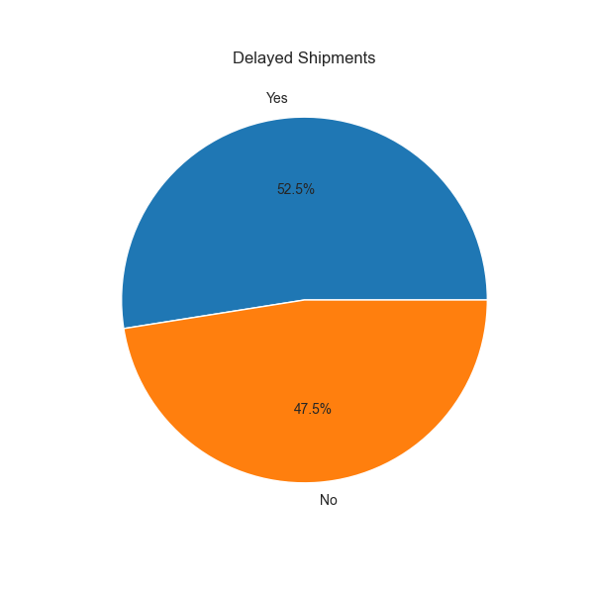
Objective
This visualization examines the percentage of shipments delivered on time versus delayed shipments. Delay analysis is one of the most important performance indicators in logistics management.

Python Code
plt.figure(figsize=(6,6))

df["Delayed"].value_counts().plot(

kind="pie",

autopct="%1.1f%%"

)

plt.ylabel("")

plt.title("Delayed Shipments")

plt.show()

Interpretation
The pie chart represents the proportion of delayed and on-time shipments within the logistics dataset.
The majority of shipments were delivered successfully without delay, indicating satisfactory operational performance. However, a noticeable percentage of shipments experienced delays.
Possible reasons include:
- Traffic congestion
- Vehicle breakdown
- Weather conditions
- Warehouse processing delays
- Route inefficiencies
- Driver availability
- Fuel shortages
- Unexpected operational disruptions
Although delayed shipments represent a smaller proportion of the dataset, they have a significant impact on customer satisfaction and operational costs.

Business Insight
Regular monitoring of delayed shipments helps companies:
- Improve delivery performance.
- Increase customer satisfaction.
- Reduce compensation costs.
- Improve route planning.
- Monitor driver performance.
- Enhance warehouse coordination.

Conclusion
Reducing shipment delays should remain one of the primary objectives of every logistics organization because delivery reliability directly influences customer trust and business reputation.

Visualization

Key Findings
The exploratory data analysis generated several valuable insights into logistics operations.
Major Findings
1. Delivery Performance
Most shipments were delivered within the expected delivery period, indicating satisfactory operational efficiency.

2. Transportation Cost
Transportation cost increased as shipment distance and shipment volume increased.

3. Regional Performance
Certain regions handled significantly more shipments than others, indicating differences in customer demand and operational workload.

4. Shipment Volume
Shipment volume remained relatively stable throughout the study period, with moderate seasonal fluctuations.

5. Delayed Deliveries
A limited percentage of shipments experienced delays, highlighting opportunities for improving operational efficiency.

6. Correlation Analysis
Strong positive relationships were observed between:
- Distance and Transportation Cost
- Shipment Volume and Cost
- Delivery Time and Distance

7. Resource Utilization
Vehicle utilization appeared balanced across shipment categories, although peak demand periods may require additional transportation capacity.

Business Recommendations
Based on the analytical findings, the following recommendations are proposed.
1. Route Optimization
Use AI-based route optimization algorithms to reduce travel distance and fuel consumption.

2. Real-Time GPS Tracking
Monitor shipment movement continuously to improve delivery accuracy and reduce delays.

3. Predictive Analytics
Forecast future shipment demand using historical logistics data.

4. Warehouse Automation
Automate warehouse operations to reduce loading and unloading delays.

5. Fleet Management
Monitor vehicle utilization and schedule preventive maintenance.

6. Driver Performance Monitoring
Track driver efficiency and delivery performance using KPIs.

7. Fuel Cost Management
Analyze fuel consumption regularly to identify cost-saving opportunities.

8. Dashboard Reporting
Develop Power BI or Tableau dashboards for real-time logistics monitoring.

9. Inventory Optimization
Maintain optimal inventory levels to avoid unnecessary transportation costs.

10. Machine Learning Integration
Future logistics systems should incorporate machine learning models for demand forecasting and delivery prediction.

Future Scope
The present project demonstrates only exploratory data analysis.
Future work can include:
- Machine Learning models
- Delivery Time Prediction
- Transportation Cost Prediction
- Route Optimization Algorithms
- Inventory Forecasting
- Demand Forecasting
- Customer Satisfaction Analysis
- Warehouse Performance Analysis
- IoT-based Logistics Monitoring
- AI-powered Fleet Management
- Real-time GPS Analytics
- Predictive Maintenance
- Big Data Analytics
- Cloud-based Logistics Dashboards
- Digital Supply Chain Management
Modern logistics organizations increasingly rely on Artificial Intelligence, Internet of Things (IoT), Cloud Computing, and Predictive Analytics to improve operational efficiency and customer satisfaction.

Conclusion
This project successfully demonstrated the application of Python-based data analytics techniques to logistics operations. A hypothetical logistics dataset consisting of shipment information was analyzed using exploratory data analysis, statistical methods, and multiple visualization techniques.
The analysis revealed meaningful relationships among transportation cost, delivery time, shipment volume, and travel distance. Various graphical techniques such as histograms, scatter plots, bar charts, pie charts, boxplots, and heatmaps provided valuable insights into logistics performance.
The findings indicate that data analytics plays a critical role in improving transportation planning, reducing operational costs, optimizing delivery schedules, and enhancing customer satisfaction. Businesses that utilize data-driven decision-making can identify operational bottlenecks, allocate resources efficiently, and improve overall supply chain performance.
The project also strengthened practical skills in Python programming, data preprocessing, exploratory data analysis, and business interpretation. These skills are highly valuable for careers in Data Analytics, Logistics Analytics, and Supply Chain Management.
Overall, this internship task successfully demonstrated how analytical techniques can transform raw logistics data into actionable business intelligence, enabling organizations to make informed decisions and improve operational excellence.

Important Python Code Snippets
This section presents the major Python code snippets used throughout the project. These scripts demonstrate the complete workflow of loading the dataset, performing exploratory data analysis (EDA), calculating statistical measures, and generating visualizations. Python was selected because of its simplicity, scalability, and powerful data analysis ecosystem built around libraries such as Pandas, NumPy, Matplotlib, and Seaborn. These libraries are widely used for logistics and supply chain analytics.

1. Import Required Libraries
import pandas as pd
import numpy as np
import matplotlib.pyplot as plt
import seaborn as sns

sns.set_style("whitegrid")
Purpose:
- Import data analysis libraries.
- Enable statistical visualization.
- Configure plotting style.

2. Load Dataset
df = pd.read_excel("logistics_data.xlsx")
Purpose
This command imports the logistics dataset into a Pandas DataFrame, allowing structured analysis and manipulation of shipment records.

3. Initial Data Inspection
print(df.head())

print(df.info())

print(df.describe())
Purpose
These functions provide an overview of the dataset, including column names, data types, missing values, and descriptive statistics.

4. Missing Value Analysis
df.isnull().sum()
Purpose
Checks whether any missing values exist in the dataset before analysis.

5. Correlation Matrix
corr = df.corr(numeric_only=True)
print(corr)
Purpose
Calculates relationships among numerical logistics variables.

6. Delivery Time Histogram
sns.histplot(df["Delivery_Time_Days"], bins=20, kde=True)
Purpose
Visualizes the distribution of delivery times.

7. Correlation Heatmap
sns.heatmap(corr, annot=True, cmap="coolwarm")
Purpose
Displays the strength of relationships between logistics variables.

8. Scatter Plot
sns.scatterplot(
data=df,
x="Transportation_Cost",
y="Delivery_Time_Days"
)
Purpose
Shows the relationship between transportation cost and delivery time.

Project Summary
This project demonstrates the practical application of Python-based exploratory data analysis in logistics operations. The workflow began with loading and inspecting a hypothetical logistics dataset, followed by data preprocessing, descriptive statistical analysis, correlation analysis, and graphical visualization.
Several visualization techniques—including histograms, bar charts, line charts, scatter plots, pie charts, boxplots, and heatmaps—were used to understand shipment patterns, transportation costs, delivery times, and regional performance. Visualization plays a key role in exploratory analysis by making trends, outliers, and relationships easier to interpret.
The project highlighted that:
- Transportation cost generally increases with shipment distance.
- Delivery time varies depending on shipment characteristics and operational conditions.
- Regional shipment analysis helps identify high-demand areas.
- Delay analysis supports service quality improvement.
- Statistical visualization assists organizations in making evidence-based decisions.
Overall, the project enhanced practical skills in:
- Python Programming
- Pandas
- NumPy
- Matplotlib
- Seaborn
- Exploratory Data Analysis (EDA)
- Statistical Analysis
- Business Interpretation
- Logistics Analytics
These skills are valuable for careers in Data Analytics, Business Intelligence, and Supply Chain Management.

References
The following resources were referred to for understanding logistics analytics concepts, Python programming, and data visualization techniques.
Books
- Jake VanderPlas, Python Data Science Handbook, O'Reilly Media.
- Wes McKinney, Python for Data Analysis, O'Reilly Media.
- Bowersox, Closs & Cooper, Supply Chain Logistics Management.
- Ronald H. Ballou, Business Logistics and Supply Chain Management.
Documentation
- Python Official Documentation
- Pandas Documentation
- NumPy Documentation
- Matplotlib Documentation
- Seaborn Documentation
These libraries are commonly used for loading, cleaning, analyzing, and visualizing tabular data in Python.

Appendix A – Dataset Sample
Suggested Caption
Figure A.1: Sample of the Logistics Dataset
Description
The logistics dataset contains 500 shipment records representing transportation activities over a one-year period. Each record includes shipment identifiers, booking dates, shipment volume, transportation cost, travel distance, vehicle type, delivery time, and delay status.
The dataset was designed to simulate realistic logistics operations and support exploratory data analysis. It provides sufficient information to evaluate operational performance and identify opportunities for process improvement.

Dataset Statistics
- Number of Records: 500
- Number of Columns: 11
- Data Type: Structured Tabular Data
- File Format: Microsoft Excel (.xlsx)

Appendix B – Graph Gallery
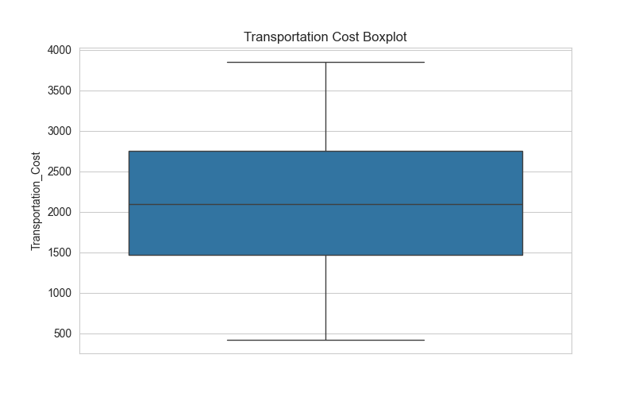
Figures Included
Figure 1 – Distribution of Delivery Time
Figure 2 – Shipment Volume Distribution
Figure 3 – Transportation Cost Distribution
Figure 4 – Correlation Heatmap
Figure 5 – Region-wise Shipment Analysis
Figure 6 – Monthly Shipment Trend
Figure 7 – Delayed Shipment Analysis
Figure 8 – Boxplot of Transportation Cost

Final Remarks
This internship project successfully demonstrated how Python can be used to analyze logistics data through Exploratory Data Analysis (EDA). By applying statistical methods and visualizations, the project transformed raw shipment records into actionable business insights. Such analytical approaches enable organizations to improve delivery performance, optimize transportation costs, and make informed strategic decisions, reinforcing the importance of data-driven logistics management.

